World No Tobacco Day Resource Sheet from Children for Health on Smoking & Tobacco

Use these materials to design and develop your programmes to reach children and young adolescents. If you need help to adapt it or to find out more about our unique 7-step approach, let us know. This is what we do!

Slogans

Here are some examples:
- A deadly threat to health and fitness
- Be smart – don’t start!
- Easy to start hard to stop
- Smokers Smell

Why children and young adolescents should learn about tobacco and smoking?
- Children your age sometimes face pressure to start smoking from your friends.
- You may have family members or older children around who you see smoking, and advertising companies make smoking seem attractive.
- To help you decide, you should know how tobacco could badly affect your health and the health of others in your family.
- You can learn about safer ways to cope with stress and keep your body and minds healthy and working to improve your life.
- You need to learn critical thinking skills to help you think for yourselves.
- Learn how to resist pressure and be assertive in making your own choices.
- Know how you are a role model for other younger children too.

The Smoking and Health Facts those children and young adolescent need to know

Smoking causes disease and poor health

- Cigarettes can cause cancer and heart disease. People who don’t smoke are usually healthier and fitter than those who do smoke.
- Smoking harms non-smokers. When people breathe in others’ cigarette smoke, they are also harmed. If a pregnant mother breathes in smoke, it can harm the unborn baby.
- Smoking is expensive and takes money that could be used for food, clothes, and another things.
- Smoking is addictive: once people start, it is very difficult to stop.
- As young people we can think for ourselves and make healthy choices.

Smoking can cause cancer in the lung, throat, mouth and bladder
Cancer occurs when body cells grow out of control and form a lump called a tumour. A cancer is serious because it prevents that part of the body from working properly. It can spread to other parts of the body and cause death. It is expensive to cure and often cannot be cured. We cannot catch cancer from other people.

Heart disease
Smoking makes the heart work harder. It increases the heart rate because there is less oxygen in the blood when people smoke. Children who play sport cannot play as well if they smoke. When they get older they are more likely to suffer from heart disease.

Lung damage
Tobacco contains tar, which stops the lungs from cleaning themselves properly. Smoking injures people’s lungs so that they:
- Get more coughs and colds
- Are short of breath after exercise
- Cough every day, especially when they wake up
- Bring up thick, sticky mucus when coughing
- Feel generally unwell.

Smoking is harmful to others

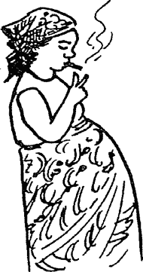
Harmful to babies
If a mother smokes, or breathes in another’s smoke, the chemicals in the cigarette can harm her unborn baby. Babies can be born smaller and weaker, or even die if their mother smokes. Babies and young children can get chest problems – coughs and wheezes – if their parents smoke.

Smoke from cigarettes harms others who don’t smoke
Smoke causes eye and throat irritation, coughing and even cancer. Non-smokers still breathe in the smoke of those near them. Some people may be so affected by tobacco smoke, especially those with chest trouble, that they find it difficult to breathe.

Smoking harms the environment
Cigarettes and matches cause fires when they are thrown away carelessly. At home people’s lives may be in danger. Burning cigarettes and matches also cause fires in fields and forests, markets, petrol stations, football stadiums, cinemas, and even in vehicles.

Cigarettes are poisonous

Cigarettes contain many harmful chemicals:
- Tar - a sticky mixture of irritating chemicals and cancer-causing substances that collects in the lungs.
- Nicotine - a poisonous drug that makes the heart beat faster, and also affects blood vessels and nerves. It is very addictive.
- Carbon monoxide and other poisonous gases – which take the place of oxygen in the blood, which the body needs to, stay healthy.

A costly habit

- Money is wasted on cigarettes instead of buying useful things for the family.
- Land, which could be used for growing food, is instead used for growing tobacco for cigarettes or for chewing.
- Smokers are ill more often than those who do not smoke, so they are unable to work and need more medical attention.
- Governments have to spend money trying to stop people from smoking and paying for their health care, while cigarette companies spend a lot of money trying to get people to smoke.

Why do people begin smoking?

- They see others smoking, like their friends, parents, brother or sister, and they want to try it.
- They feel peer pressure from their friends to try smoking.
- They get good feelings from the sharing of a habit and the rituals around smoking.
- It may make young people feel older, part of a cool crowd, look busy, have something to give and talk about (bonding).
- They see advertisements, which encourage them to buy cigarettes. The adverts make the smokers seem attractive, young, healthy and rich. It associates smoking with a positive, successful lifestyle.

Smoking can affect relationships

- Many people, who do not smoke, do not like the smell of smoke.
- Smoking causes the hair and breathe and even fingers to smell unpleasant.
- Non-smokers can find smokers unattractive.
- Smokers will be spending money that could be spent on other things that are needed by the family or on fun leisure activities.

Giving up cigarettes

- Many people want to feel better by giving up smoking. It is difficult at first, as people may feel quite ill. They may have: poor sleep; bad dreams; difficulty in thinking and concentrating; depression and anxiety; and a craving for cigarettes. This does not last.
- Friends and family can help a person who is trying to stop smoking. Before long, they will feel better and be healthier.
- Their clothes and their breathe and hair will not smell of cigarette smoke.

Giving up your health so cigarette companies can make money

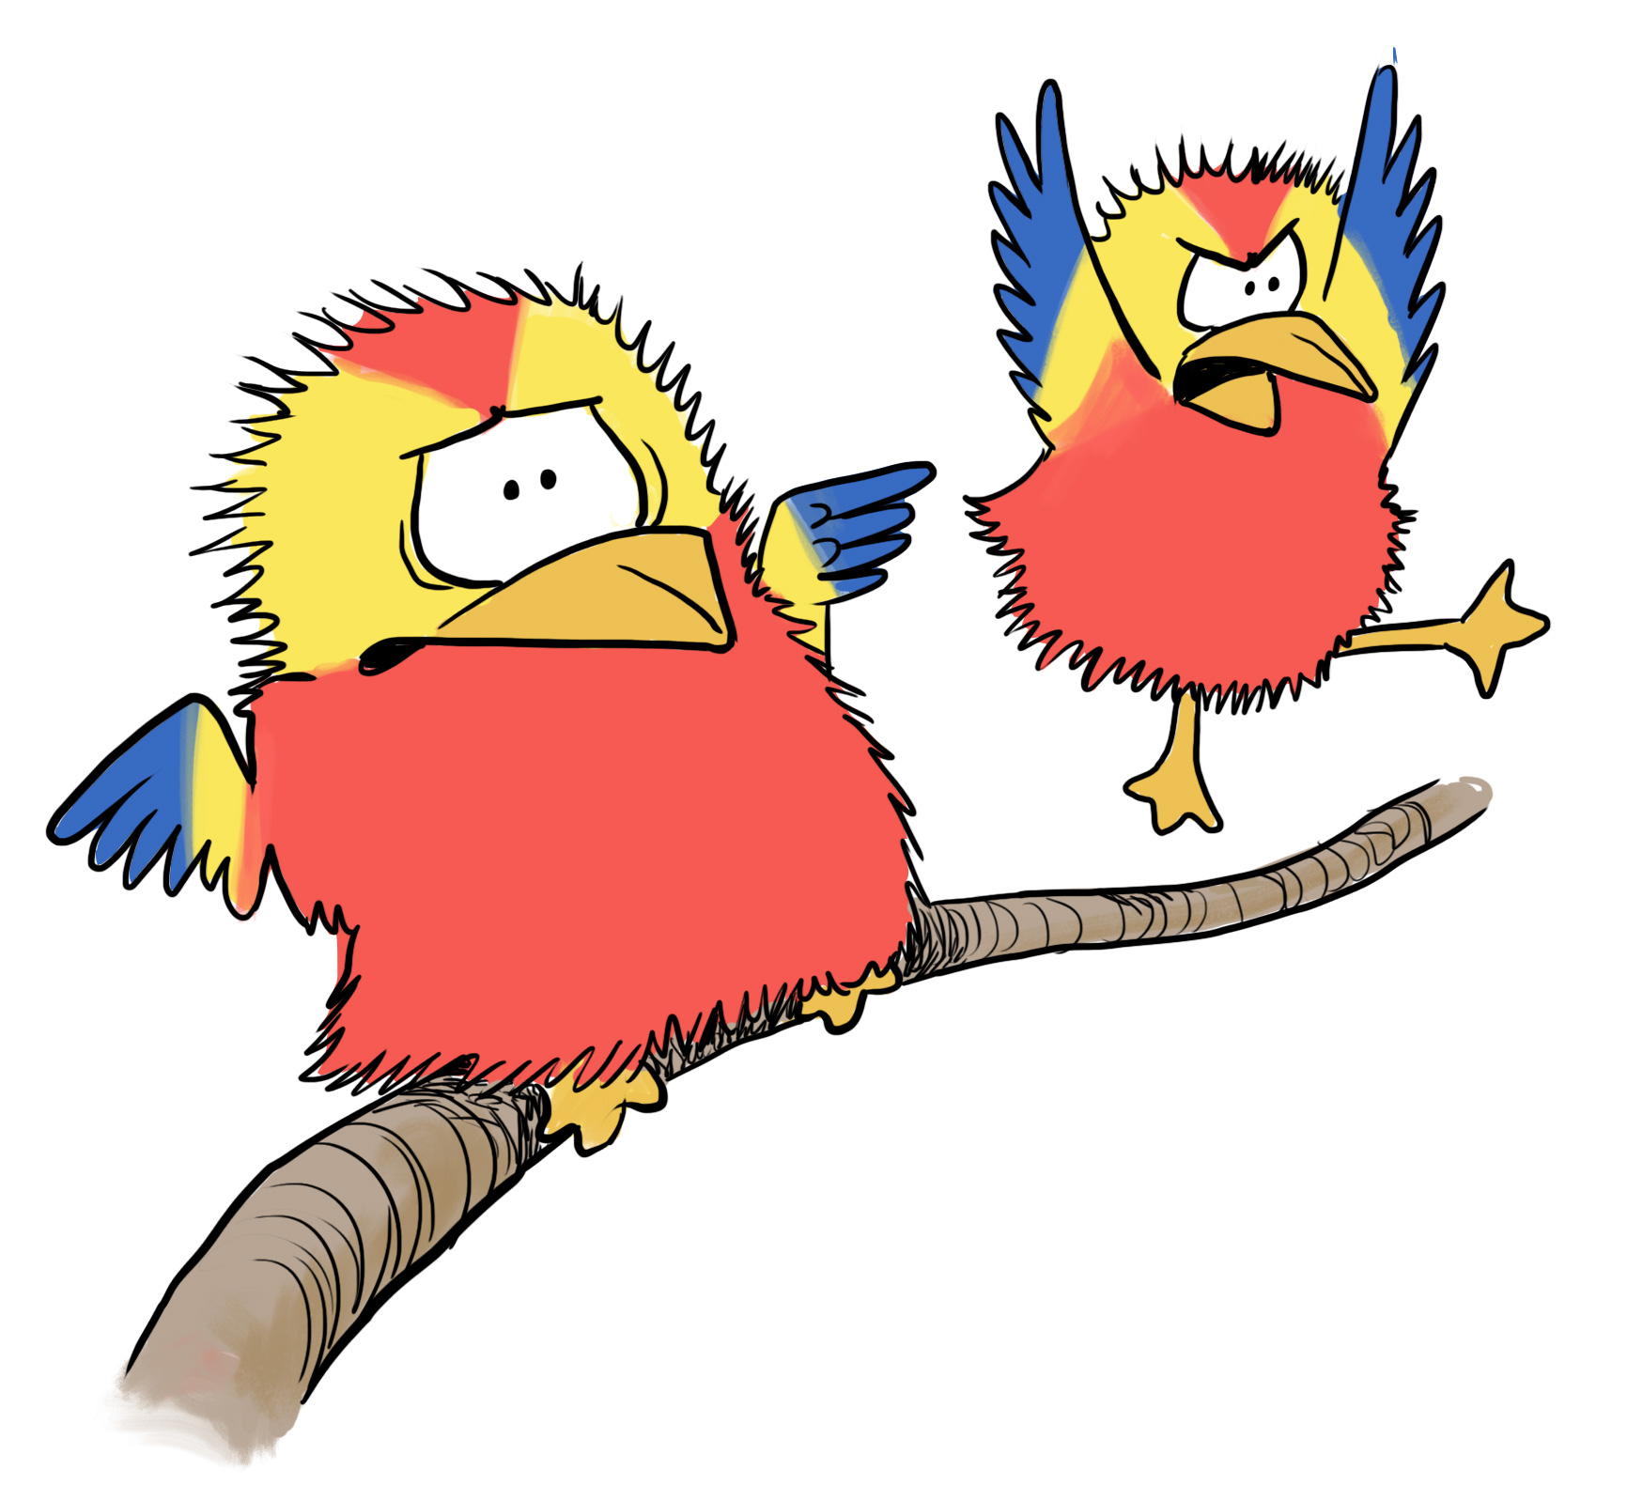
In some countries, many people are deciding not to smoke. This means less money for the cigarette companies, so they want to encourage people in other countries to smoke more. They use advertising to get new customers. Don’t let the cigarette companies tell you what to do! Make up your own mind! Think for yourself!
ZuZu and ZaZa are Children for Health mascots who help to question and guide children’s action in a fun and lively way. They appear in our story books, on our posters and are actual puppets which are used in workshops. Partners often buy them to be used in school health clubs.

Things to do with children and young people to get the messages to ‘stick’ and spread

Here are some types of activities that teachers or youth workers can do with children and young adolescents. They are set out in no particular order. Part of our work with partners is to select, adapt and create content that ‘fits’ with the context in which it is being used. In the case of children and young adolescents it will be important to get a clear understanding of their home and community life, expectations, educational levels.

1. Find out about smoking in your community
- What are the local names given to cigarettes and smoking?
- When are children and young people exposed to tobacco smoke?
- What are local attitudes and laws about smoking?
- What information can you find about tobacco, smoking in the health clinic or the school textbooks?
- Does the government put a health warning on the advertisements? What does it read and why?

- Survey billboards and advertisements from newspapers, magazines, TV, the radio and cinemas. How often are cigarettes advertised?
- What ideas do the advertisements give?
- How do they make you feel?
- What do the advertisements NOT tell you

3. Find out about smoking in the family.
Find out how many children in the group have parents, guardians, brothers or sisters who smoke. Talk about how smoking affects the whole family.
- What is it like to live with a smoker?
- Does the fact that someone in the family smokes make it more likely that the children will begin to smoke? Why? Why not?
- What age did they start?
- Why did they start to smoke?
- Why do they smoke now?
- Would it be easy or hard for them to stop smoking?
- Have they tried to stop?
- What effects have they noticed on their health?
- Would they encourage young people to smoke?
- How could others help them to stop smoking?
Make a bar chart to show the number of children in the class with parents or guardians who smoke. If in a youth group - also show the number of children in the class who smoke at least one cigarette a week.

4. Using smoking or tobacco-related local resources and materials
- Bring in health education materials about smoking like pamphlets or articles in a newspaper or school textbooks.
- Divide these up between groups of children.
- Ask them to read the materials and write down the main messages and any questions they have.
- Answer their questions.
- Ask each group to present their messages.
- Examples of smoking-related classroom-based activities:

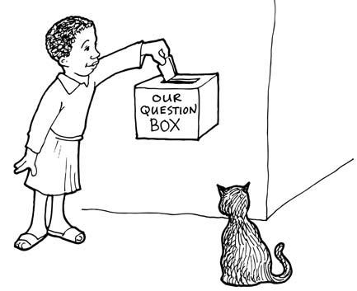
These would be adapted/developed for different age groups.

- Make a Question Box in the class, in which children can place questions about smoking. Make a time to answer these questions, or invite a health worker to come and talk with the children.
- Make up true and false statements about smoking. Do a ‘vote with your feet’ activity. Put up on the classroom walls three signs: YES – NO – DON’T KNOW. Read out each statement. The children decide which sign to stand by. Ask each group why they are standing in each place. Correct any misunderstandings.
- Read Joseph’s story and talk about the lessons he learned.

Joseph, aged 12, lived with his family in a village. One day, on the way from school, he met a group of boys from his class. They were smoking. They offered Joseph a cigarette. Joseph puffed away. At first he felt sick, but he did not want these boys to think that he was a child. He finished his first cigarette. Soon he was smoking one cigarette a day…then two, then five and then ten a day. He became addicted to cigarettes. Now he felt sick if he did not have one. Joseph began to have a bad cough. It did not get better, so he went to the health clinic.

The health worker told him that smoking caused his cough. She knew he smoked because his breath smelled and his teeth were stained yellow. ‘Girls don't like boys to smell, you know,' she said to Joseph. She also told him that smoking could cause cancer of the lungs and throat. Many people die from this. Joseph thought to himself, ‘I must try to give up smoking.'

Joseph had always been a keen footballer, but after a few months of smoking he noticed that he could not run about the pitch as quickly as he used to without getting out of breath. He was upset when he was not chosen to play for his team in a big match.

Joseph went to meet his friends outside the bicycle shop where they smoked and chatted. On the shop wall were cigarette advertisements showing famous sportspeople smoking. They looked fit and healthy. There was no one there to tell the boys that advertisements are not always honest. For a few months, Joseph was happy. But he missed the football team and began to visit the sports ground where the team was practising. He longed to play again, but he knew that he must give up smoking and start training again if he wanted his body to be fit enough. He talked to several of his friends outside the shop, and three of them agreed to try to give up smoking. It was not easy. At first Joseph felt sick and his body longed for a cigarette. Twice he started smoking again, but Joseph tried again. In the end, Joseph and one of his friends succeeded. Joseph began training again and after a while was fit enough to re-join the team.

- Analyse the motives of people who don’t smoke or who have given up
- Why did they decide not to smoke?
- When did they decide not to smoke or give up smoking?
- If they gave up smoking, how did they manage this?
- What was difficult?
- What helped them to succeed?
Invite someone who has given up smoking to come and talk to the group. Prepare questions before to ask the person. Afterwards the children can write and illustrate a report to show what they have found out.

7. Find out the costs of smoking
- Find out the cost of one cigarette.
- Ask a regular smoker how many cigarettes they smoke in one day.
- Work out the cost of the number of cigarettes smoked each day, each week, each month, and for a whole year.
- Workout how much rice, flour or meal this money could buy.

8. Understand about the poisonous substances in cigarettes
- Ask an adult smoker to take a white cloth and blow tobacco smoke through it. A brown stain will appear on the cloth. This is tar which collects in smokers’ lungs.
- Make a ‘smoking bottle’. This is a low cost activity that makes a very powerful point about the noxious gases in a cigarette.

The Smoking Bottle Experiment
Make a model of a smoker using a plastic bottle with a hole made in it. Squeeze and release the bottle to make the model smoke. Observe the effect of smoke on the model (the look and the smell)

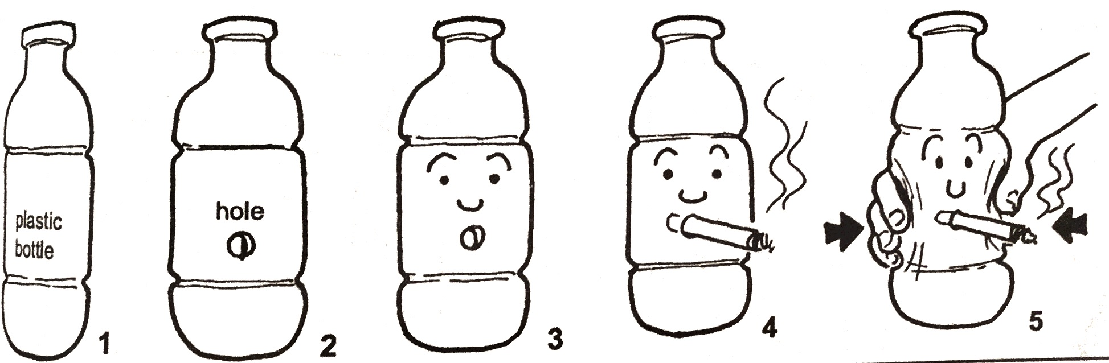

9. Organise a debate.
- Divide the group into two.
- One group prepares arguments in support of a topic; the other prepares arguments against it.
- Elect four to five members from each group to represent them in the debate.
- The teams sit opposite each other and take it in turns to argue their position.
- Afterwards the class votes to see which side won.
- Possible topics include:
    - Smoking should be allowed in all public places, including buses and trains.
    - The government should double the price of cigarettes through taxes.

10. Prepare a role-play
- Five children arrange to meet at their favourite place. One of them produces some cigarettes and tells the others to try. One refuses, but the others ask, ‘Why not?’
  - What does this child say?
  - How do the others try to persuade and put pressure on their friend?
  - What happens?
- Make up the role-play. Afterwards discuss what was learnt from the role-play.
- How can children resist peer pressure?

- Planning an anti-smoking campaign
- List the reasons why people smoke and why they do not smoke.
- Compare the reasons. What ideas does the list give about? For example:
  - How to encourage people to stop smoking?
  - How to help people to avoid starting to smoke?
  - That they will decide for themselves?
- Discuss and agree on their main campaign messages.
- Make picture stories to tell other children.
- Write songs and poems to teach other children.
- Make posters to display at home, at school or in other public places.
- Make role-plays to show in school or at an open day, like the story of Joseph in this sheet.
- Monitor the impact of the role-play - Have any of the children in the group stopped smoking? What about friends, brothers or sisters or parents? Have the numbers changed? For better or for worse?

- Monitoring and evaluation
Children for Health has several M&E tools to use with children and young adolescents Types of things worth finding out might include:
- Why smoking is dangerous?
- Why alcohol is dangerous?
- Have any of the group talked with others about the dangers of smoking, what happened? What would they do next time?
- Have any of them faced situations when they have been offered cigarettes since the learning on smoking? What happened?

